**1. A class CLOCK has the following members:**

**Data member: hour of type integer, minute of type integer**

**Member functions: readtime(int h, int m); showtime() to display data member, addtime(time T1, time T2). Write a program to input two different objects FT and ST, print their sum (assume 24 hr. clock time) e.g. input FT=6 hrs. 35mins, ST=3hrs 45 min then output T=FT+ST=10hrs 20min.**

#include <iostream>

using namespace std;

int h1,m1,sumh,summin;

class clock

{

int hour,min;

public :

void readtime ();

void showtime();

void addtime();

void data();

};

void clock::readtime()

{

cout << "Give the hours : ";

cin >> hour;

cout << "Enter the min : ";

cin>>min;

}

void clock::data()

{

h1=hour;

m1=min;

}

void clock::addtime()

{

sumh=h1+hour;

summin=m1+min;

if (summin>=60)

{

sumh+=1;

summin=summin%60;

}

showtime();

}

void clock::showtime()

{

cout << "Hours : " << sumh << endl;

cout << "Min : " << summin << endl;

}

int main ()

{

class clock ft,st;

ft.readtime();

ft.data();

st.readtime();

st.addtime();

return 0;

}

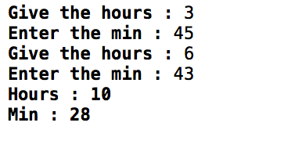

**2. Define a class worker with the following specification:**

**Roll_no integer, wno integer, wname 25 character, hrwrk,wgrate float(hrs. worked and wage rate per hour), totwage float (hrwrk*wgrate), calcwg() a function to find hrwrk*wgrate with float return type**

**Public member**

**In_data() a function to accept values of wno, wname, hrwrk, wgrate and invoke calcwg() to calculate totpay.**

**Out_data() a function to display all the data members on the screen you should give definitions of functions.**

#include <iostream>

#include<stdio.h>

#include <stdlib.h>

using namespace std;

class worker

{

  int wno;

  char wname[25];

  float hrwrk, wgrate, totwage;

  float calcwg(float,float);

  public :

  void in_data();

  void outdata();

};

float worker::calcwg(float hour,float rate)

{

    float total;

    total=hour*rate;

    return total;

}

void worker::in_data()

{

    cout << "Enter the worker no : ";

    cin >> wno;

    cin.ignore();

    cout << "enter the worker name : ";

    cin.getline(wname,25);

    cout << "Enter the rate per hour : ";

    cin >> wgrate;

    cout << "Enter the hours of work : ";

    cin >> hrwrk;

    totwage=calcwg(hrwrk, wgrate);

    outdata();

}

void worker::outdata()

{

     cout << endl;

    cout << "worker no : " << wno << endl;

    cout << "Worker name : ";

    puts(wname);

    cout << "rate per hour : " << wgrate << endl;

    cout << "hours of work : " << hrwrk << endl;

    cout << "tot wage : " << totwage << endl;

}

using namespace std;

int main()

{

   worker ob1;

   ob1.in_data();

   3

   return 0;

}

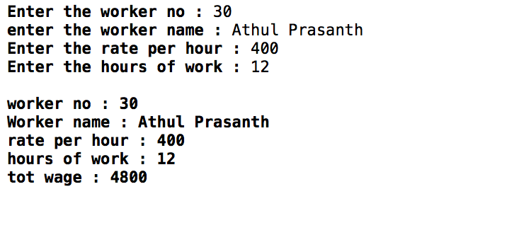

**3.Define a class student with the following specification:**

**Admno integer, sname 20 character, eng, maths, science float, total float, ctotal() a function to calculate eng+maths+science Public member function of class student**

**Takedata() function to acceot values for admno, sname, eng, maths, science and invoke ctotal() to calculate total**

**Showdata() Fuction to display all the data members on the screen.**

#include <iostream>

#include <stdio.h>

#include <stdlib.h>

using namespace std;

class student

{

    int admno;

    char sname[30];

    float eng, math,science,total;

    public :

    void ctotal();

    void takedata();

    void showdata();

};

void student::ctotal()

{

cout << endl;

    total=eng+math+science;

    cout << "total marks : " << total;

}

void student::takedata()

{

   cout << "Enter the admno ";

    cin>>admno;

    cin.ignore();

    cout<< "enter the name : ";

    cin.getline(sname,20);

    cout << "Enter the marks for eng,sci,and math resp ";

    cin>> eng >> science >> math;

    showdata();

    ctotal();

}

void student::showdata()

{

    cout << endl << "Admin no : " << admno;

    cout << endl << "Name : ";

    cout << sname;

}

int main()

{

    student ob1;

    ob1.takedata();

   return 0;

}

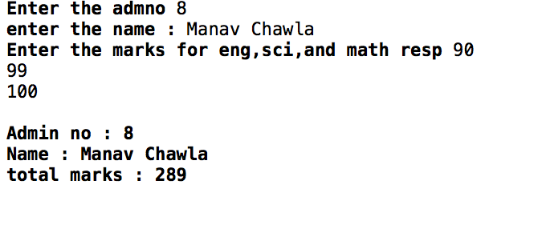

**4. A class serial has the following members:**

**Serialcode integer, title 20 character, duration float, noofepisodes integer**

**Public members are a constructor to initialize duration as 30 and noofepisodes as 10**

**Newserial() function to accept values for serialcode and title**

**Otherentries() function to assign the values of duration and noofepisodes with the help of corresponding values passed as parameters to this function.**

**Dispdata() function to display all the data members on the screen**

#include <iostream>

#include <stdio.h>

#include <stdlib.h>

using namespace std;

class serial

{

int serialcode,noofepisodes;

float duration;

char title[20];

public :

serial()

{

duration=30;

noofepisodes=10;

}

void newserial();

void otherentries(float,int);

void dispdata();

};

void serial::newserial()

{

float dur;

int noof;

cout << "Enter the title : ";

cin.getline(title,20);

cout << "Enter the serial code : ";

cin>>serialcode;

cout << "Enter the duration : ";

cin>>dur;

cout << "Enter the no of episodes : ";

cin>>noof;

otherentries(dur, noof);

}

void serial::dispdata()

{

cout << endl;

cout << "Title : ";

cout.write(title,20);

cout << endl;

cout << "Code : ";

cout << serialcode << endl;

cout << "duration : " << duration << endl;

cout << "no of episodes : " << noofepisodes << endl << endl;

}

void serial::otherentries(float dur, int noof)

{

duration=dur;

noofepisodes=noof;

dispdata();

}

int main ()

{

class serial ob1, ob2;

ob2.newserial();

ob1.dispdata();

return 0;

}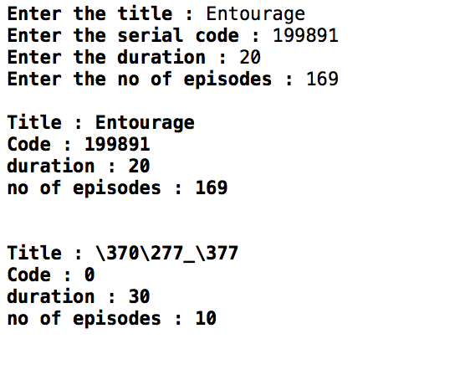

**5.A class student has three data members name, roll number, marks of 5 subjects and member function to assign streams on the basis of table given below:**

**Average Marks Stream**

**96% or more Computer Science**

**91% - 95% Electronics**

**86% to 90% Mechanical**

**81% to 85% Electrical**

**76% to 80% Chemical**

**71% to 75% Civil**

#include <iostream>

using namespace std;

class student

{

char name[20];

int roll;

float marks[5];

public :

void stream();

void read();

}stud1;

void student::read()

{

cout << "Enter name : ";

cin.getline(name,20);

cout << "enter roll no : ";

cin>>roll;

cout << "Enter marks : ";

for (int i=0; i<5;i++)

{

cin>>marks[i];

}

stream();

}

void student::stream()

{

float avg=0;

for (int i=0;i<5;i++)

{

avg=avg+marks[i];

}

avg=avg/5;

cout << "Your Stream is : ";

if (avg>=96)

{

cout << "comp science";

}

else if (avg>=91 && avg<=95)

{

cout << "Electronics";

}

else if (avg>=86 && avg<=90)

cout << "mechanical ";

else if (avg>=81 && avg<=85)

cout << "electrical ";

else if(avg>=76 && avg<=80)

cout << "chemical ";

else if (avg>=71 && avg<=75)

cout << "civil ";

else

cout << "N/A";

}

int main ()

{

stud1.read();

}

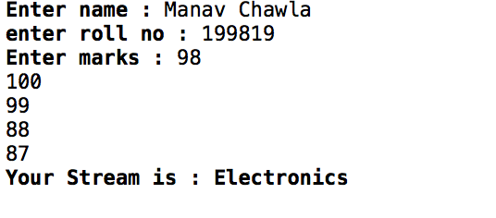

6.**Write a C++ program to process the sales activity for 20 salesman. Each salesman deals in separate product and is assigned an annual target. At the end of the month, his monthly sales is added into the salestilldate. At the end of the year, his commission is calculated as follows: if sales made is more than target then the commission is 25% of target extra sales made+10% of the target if sales made is equal to the target then the commission is 10% of the target. Otherwise commission is zero.**

#include <iostream>

using namespace std;

class salesman

{

int id;

float target,salestilldate,commission;

public :

void read();

void comm();

void show();

};

void salesman::read()

{

cout << "Enter id number : ";

cin>>id;

cout << "Enter target : ";

cin>>target;

cout << "Enter sales till date : ";

cin>>salestilldate;

comm();

}

void salesman::comm()

{

if(salestilldate>target)

commission= ((salestilldate-target)*0.25) + (target*0.10);

else if(salestilldate==target)

commission= (target*0.10);

else commission=0;

}

void salesman::show()

{

cout << endl;

cout << "ID : " << id << endl;

cout << "Target : " << target << endl;

cout << "Sales till date : " << salestilldate << endl;

if (commission>0)

{

cout << "Congrats! You commission is : " << commission << endl;

}

else

cout << "Sorry! You get no commission." << endl;

}

int main ()

{

int x;

class salesman s[20];

cout << "How many records do you want to enter? ";

cin >> x;

for(int i=0; i<x;i++)

s[i].read();

for (int i=0; i<x;i++)

s[i].show();

return 0;

}

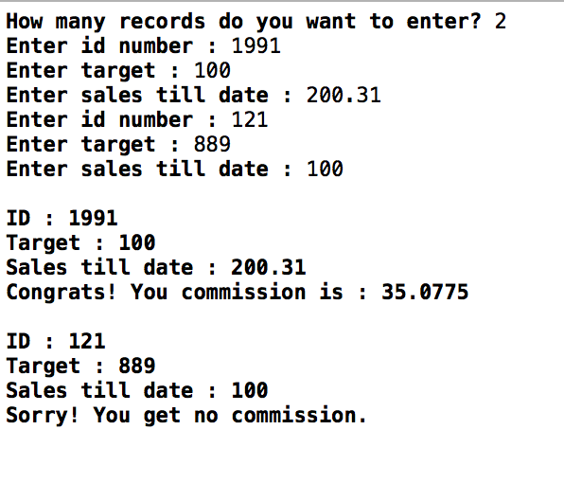

**7. Write a C++ program to simulate an arithmetic calculator for integers. The program should be able to produce the last result calculated and the number of arithmetic operations performed so far. Any wrong operation is to be reported.**

#include<iostream>

using namespace std;

class calculator

{

int ans, f, s;

char symbol;

public:

void cal();

void last();

};

calculator c1;

void calculator::cal()

{

cout<<" Enter first number- ";

cin>>f;

cout<<" Enter second number- ";

cin>>s;

cout<<" Enter '+' to add the two numbers, '-' to subtract them, '*' to multipy them or '/' to divide them- ";

repeat1:

cin>>symbol;

switch(symbol)

{

case '+': ans = f + s;

cout<<" The sum of the two number is "<<ans<<".\n\n";

break;

case '-': ans = f - s;

cout<<" The answer is "<<ans<<".\n\n";

break;

case '*': ans = f * s;

cout<<" The product of the two number is "<<ans<<".\n\n";

break;

case '/': if (s == 0)

{

cout<<" The operation is incorrect. \n\n";

break;

}

ans = f / s;

cout<<" The quotient of the two number is "<<ans<<".\n\n";

break;

default: cout<<" The entered selection is not available. Please re-enter the selection- ";

goto repeat1;

}

}

void calculator::last()

{

cout<<" The last result calculated was "<<ans<<".\n\n";

}

int main()

{

int sel=0;

repeat2:

cout<<"\n 1. Calculator \n 2. Last Result Calculated \n 3. Exit \n\n";

cout<<" Please enter the numbers 1-3 to select the corresponding options- ";

repeat:

cin>>sel;

if (sel == 1)

{

c1.cal();

goto repeat2;

}

else if (sel == 2)

{

c1.last();

goto repeat2;

}

else if (sel == 3)

;

else

{

cout<<"The given selection does not exist. Please re-enter the number- ";

goto repeat;

}

return 0;

}

